Co-pilot agent mode

https://www.youtube.com/watch?v=Z6BYhJl9hV8

Co-pilot chat window

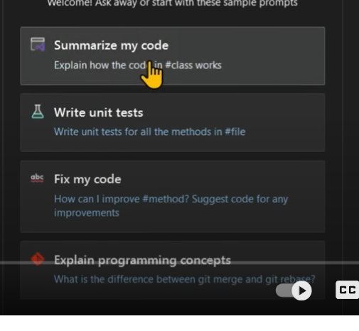

- Summarize my code
- Write unit tests
- Fix my code

We can change models in the chat window .

In the chat window you can write . What is this application doing , how is it built , and what are the key components .

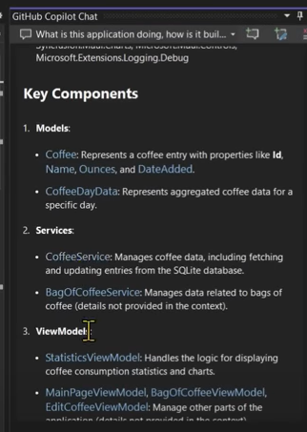

We have context menu’s also all along the code , describe with co-pilot

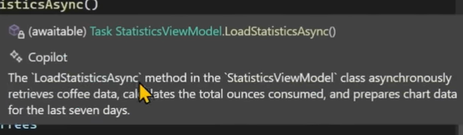

Select a particular code , and say ask co-pilot . (/doc , /explain , /fix , /help , /optimize , /tests)

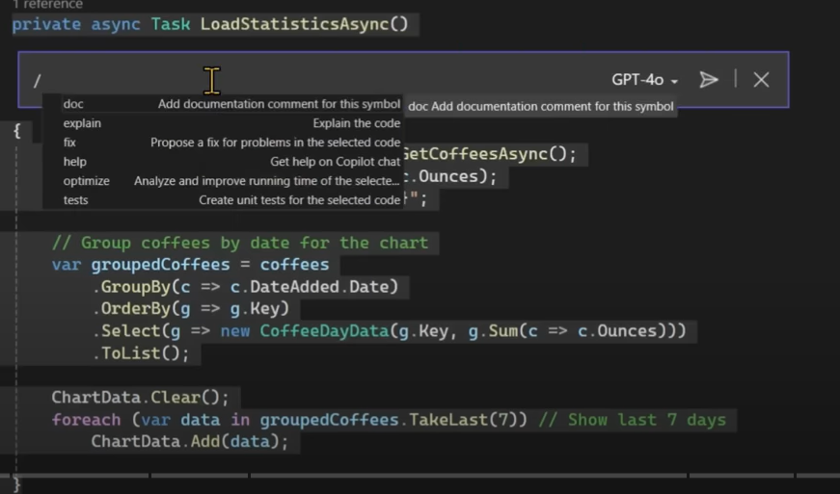

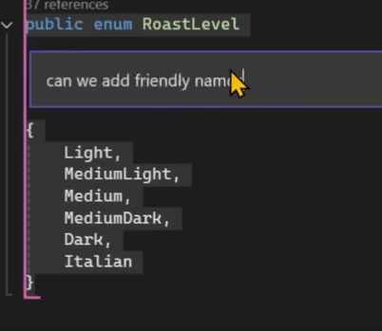

Select code and ask co-pilot , can we add friendly names .

Select code /doc , add documentation to the code .
During debugging also we can ask co-pilot , to explain items .
When encountered with the exception , it throws the Argument exception .
Click on any of the suggestions , preview it and accept the changes .

In the chat we also have , create new edit threads. I would like to add a delete button to #uipage and update #modelclass and update #service
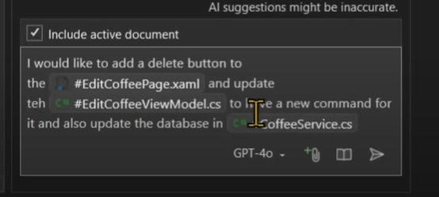
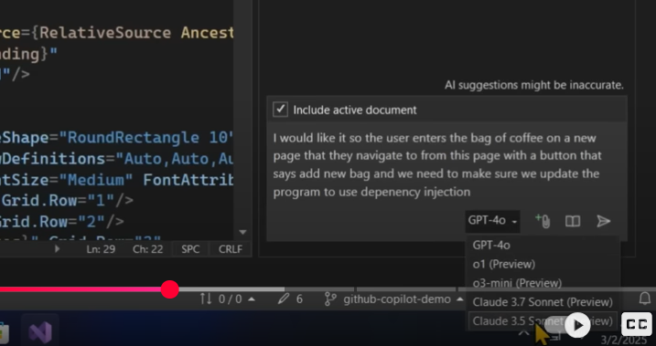

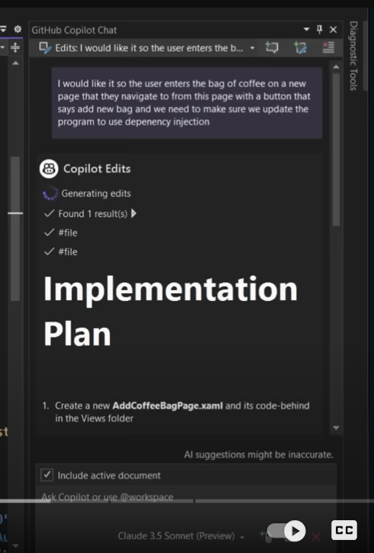

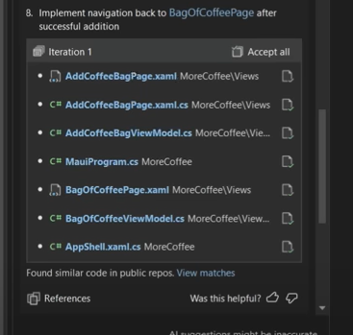

Inline code suggestion , by typing doubles slashes
//group the coffes by name for chartdata2

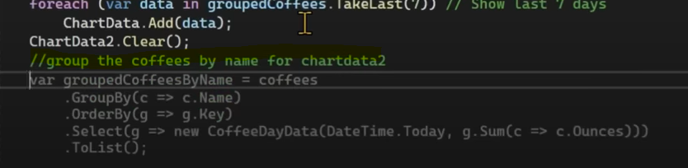

Generate commit message for me , icon while committing the code
View changes with co-pilot

